B.TECH
(LET - FINAL)
Direction (Question No. 1 and 2): Pick out the correct form of reported speech for the following.
1. Pick out the correct form of reported speech for the following.
The leader said to his followers: “I belong to the past. I am history.”
(A) | The leader cried to his followers that he belong to the past and he was history.
(B) | The leader suggested to his followers that he belonged to the past and he was history.
(C) | The leader told his followers that he belonged to the past and he was history.
(D) | The leader lamented that he belonged to the past and he was history.

2. Pick out the correct form of reported speech for the following.
The Professor said to his student: “You were right.”
(A) | The Professor said to his student that he was right.
(B) | The Professor told his student that he was right.
(C) | The Professor declared that his student was right.
(D) | The Professor told his student that he had been right.

Direction (Question No. 3 to 5):
3. Fill in the blanks with the correct answer selected from the choice given below.
Why ………. I herespan?
(A) | may
(B) | shall
(C) | am
(D) | have

4. Fill in the blanks with the correct answer selected from the choice given below.
Nobody ………. your department wanted to do that.
(A) | at
(B) | about
(C) | in
(D) | for

5. Fill in the blanks with the correct answer selected from the choice given below.
He was sure ………. her love.
(A) | about
(B) | of
(C) | in
(D) | at

Direction (Question No. 6 to 8):
6. Fill in the blanks with the correct answers selected from the choice given below:
I …………… tennis every Sunday morning.
(A) | playing
(B) | play
(C) | am playing
(D) | am play

7. Fill in the blanks with the correct answers selected from the choice given below:
Don’t make so much noise. Noriko …………… to study for her ESL test.
(A) | try
(B) | tries
(C) | tried
(D) | is trying

8. Fill in the blanks with the correct answers selected from the choice given below:
…………… many times every winter in Frankfurt.
(A) | It snows
(B) | It snowed
(C) | It is snowing
(D) | It is snow

Direction (Question No. 9 and 10):
9. Select the correct form of passive voice for the following.
I did this work.
(A) | This work is done by me.
(B) | This work had been done by me.
(C) | This work was done by me.
(D) | The work is done by me.

10. Select the correct form of passive voice for the following.
Who wrote “The Discovery of India”?
(A) | By whom is “The Discovery of India” written?
(B) | By whom had been “The Discovery of India” written?
(C) | By whom was “The Discovery of India” written?
(D) | “The Discovery of India” was written by whom?

Direction (Question No. 11 and 12):
11. Select the most appropriate contextual meaning for the following underlined words.
The event took place in December.
(A) | started
(B) | occurred
(C) | functioned
(D) | sanctioned

12. Select the most appropriate contextual meaning for the following underlined words.
The three day annual festival was held in Delhi.
(A) | regular
(B) | happening every year
(C) | special
(D) | interesting

Direction (Question No. 13 and 14):
13. Select the correct form of ACTIVE VOICE for the following.
The patients will be examined by a group of doctors.
(A) | A group of doctors will examine the patients.
(B) | A group of doctors examine the patients.
(C) | Doctors will examine the patients.
(D) | The doctors can examine the patients.

14. Select the correct form of ACTIVE VOICE for the following.
Where was her mobile hidden by you?
(A) | Where had you hidden her mobile?
(B) | Where did you hide her mobile?
(C) | Where had you been hiding her mobile?
(D) | Where will you hide her mobile?

Direction (Question No. 15 and 16):
15. Select the correct question tag for the following:
She isn’t Australian, …………...?
(A) | is she
(B) | does she
(C) | isn’t she
(D) | can she

16. Select the correct question tag for the following:
She doesn’t speak Spanish, …………...?
(A) | is she
(B) | won’t she
(C) | can’t she
(D) | does she

Direction (Question No. 17 and 18):
17. Select the word which is the most similar in meaning for the following.
Spinster
(A) | an ugly lady
(B) | a morose woman
(C) | an unmarried woman
(D) | an old woman

18. Select the word which is the most similar in meaning for the following.
Expel
(A) | send out
(B) | laugh at
(C) | irritate
(D) | dismiss

Direction (Question No. 19 and 20): Three of the four words given below are spelt wrongly.
19. Select the word that spelt correctly.
(A) | Entrepreneurship
(B) | Enterprenership
(C) | Unterpreneurship
(D) | Enterpernership

20. Select the word that spelt correctly.
(A) | Tommorow
(B) | Tomorrow
(C) | Tommrow
(D) | Tommorrow

21. The number of ways four boys can be seated around a round-table in four chairs of different colours is
(A) | 24
(B) | 12
(C) | 23
(D) | 64

22. The function increases in the interval
(A) | (1, ∞)
(B) | (, ∞)
(C) | (, ∞)
(D) | (0, ∞)

23. Angle of intersection of the curve and is equal to
(A)
(B)
(C)
(D)

24. is equal to
(A)
(B)
(C)
(D)

25. is equal to
(A)
(B)
(C)
(D)

26. The solution of the differential equation is
(A)
(B)
(C)
(D)

27. The solution of the differential equation is Then c₁ is
(A) | 1
(B)
(C)
(D) | 2

28. If the value of the determinant is positive, then
(A)
(B)
(C)
(D)

29. The order and degree of the differential equation are respectively
(A) | 1, 2
(B) | 2, 1
(C) | 2, 2
(D) | 3, 2

30. The solution of is
(A) | [8], [6]
(B) | [6], [14]
(C) | [6], [13]
(D) | [8], [14], [16]

31. The value of x that satisfies , is
(A)
(B)
(C)
(D)

32. is equal to
(A) | 1
(B)
(C) | 2
(D) | 4

33. For any two sets A and B, equals
(A) | B
(B)
(C)
(D)

34. A polygon has 44 diagonals. The number of its sides is
(A) | 10
(B) | 11
(C) | 12
(D) | 13

35. The number of natural numbers between 17 and 80 which are divisible by 6 is
(A) | 21
(B) | 11
(C) | 63
(D) | 42

36. The sum of all even natural numbers less than 75 is
(A) | 1406
(B) | 1046
(C) | 1480
(D) | 1840

37. The sum 6 + 15 + 24 + 33 + … + 105 is
(A) | 666
(B) | 333
(C) | 999
(D) | 444

38. The sum up to n terms is
(A)
(B)
(C)
(D)

39. If find the value
(A)
(B)
(C)
(D)

40. The value of is
(A)
(B)
(C)
(D)

41. Let Then is
(A)
(B)
(C)
(D) | 0

42. If then is
(A)
(B)
(C)
(D)

43. Let be 3 vectors, such that , Then is equal to
(A) | 0
(B)
(C) | 7
(D) | 1

44. The angle between the planes
(A) | 30°
(B) | 60°
(C) | 45°
(D) | 90°

45. The particular integral of the differential equation is
(A)
(B)
(C)
(D)

46. If then the value of θ in the first quadrant is
(A)
(B)
(C)
(D)

47. The value of is
(A) | positive
(B) | 1
(C) | 0
(D) | negative

48. is equal to
(A)
(B)
(C)
(D)

49. The solution of the differential equation is
(A)
(B)
(C)
(D)

50. A tetrahedron has vertices at and . Then the angle between the faces and is
(A)
(B)
(C)
(D)

51. If , then
(A) | A
(B) | I
(C) | 0
(D) | 5I

52. If is identity matrix of order 3, then
(A) | 0
(B) | 3I₃
(C) | I₃
(D) | 2I₃

53. For two sets A and B, and Then minimum number of elements in is equal to
(A) | 4
(B) | 6
(C) | 2
(D) | 1

54. The marks out of 40 in a class containing 15 students in a test are
16, 25, 35, 20, 0, 12, 30, 22, 5, 8, 4, 38, 32, 2, 1.
Then the median score is:
(A) | 16
(B) | 30
(C) | 22
(D) | 7

55. The period of the function is
(A) | π
(B) | 2π
(C) | 3π
(D) | 6π

56. If α and β are roots of then equation with roots is
(A)
(B)
(C)
(D)

57. The equation of the line through (3, 4) and parallel to the line is
(A)
(B)
(C)
(D)

58. The members of the family of lines where pass through the point
(A)
(B)
(C) | (1, 1)
(D)

59. If and then
(A)
(B)
(C)
(D)

60. The value of the determinant is equal to
(A) | 0
(B) | 1
(C)
(D) | 2

61. is equal to
(A)
(B)
(C)
(D)

62. If then
(A) | where n is an integer
(B) | where n is an integer
(C) | where n is an integer
(D) | where n is an integer

63. If and , then is equal to
(A) | 4
(B) | 8
(C) | 16
(D) | 32

64. If then the value of k is equal to
(A) | 0
(B) | 1
(C)
(D) | 2

65. The general solution of is
(A)
(B)
(C)
(D)

66. The angle between the planes and is
(A)
(B)
(C)
(D)

67. The vector with the initial point (3, 2) and the terminal point is
(A)
(B)
(C)
(D)

68. Five horses are in a race. Mr. A has selected two of the horses at random and bets on them. The probability that Mr. A selected a winning horse is
(A)
(B)
(C)
(D)

69. is equal to
(A)
(B)
(C)
(D)

70. The solution of and at x = 0 is
(A)
(B)
(C)
(D)

ENGINEERING MECHANICS
(FINAL)

71. The dimensional formula ML²T^{–3} represents
(A) | work
(B) | power
(C) | force
(D) | momentum

72. Newton’s first law of motion gives the concept of
(A) | work
(B) | force
(C) | inertia
(D) | energy

73. A system of three forces acts on a body and keeps it in equilibrium. The forces need to be
(A) | coplanar only
(B) | concurrent only
(C) | coplanar as well as concurrent
(D) | coplanar but may or may not be concurrent

74. The magnitude of two forces is such that when acting at right angles produce a resultant force of and when acting at 60° produce a resultant equal to . The forces have a magnitude of
(A) | and
(B) | 4 and
(C) | 2 and 4
(D) | 2 and

75. A car travels from one station to another along a straight road. First half of the distance is covered with velocity 60 km/hr and the second half is covered with velocity 90 km/hr. The average speed of the car is
(A) | 72 km/hr
(B) | 75 km/hr
(C) | 78 km/hr
(D) | None of the above

76. A particle starts with a velocity of 2 m/s and moves on a straight line track with retardation of 0.1 m/s². The time at which the particle is 15 m from the starting point would be
(A) | 10 s
(B) | 20 s
(C) | 40 s
(D) | 60 s

77. A train travels between two stations 20 km apart in 24 minutes. During the journey, the train accelerates uniformly from some distance and then has a uniform retardation. The maximum velocity attained by the train during the journey will be
(A) | 80 km/hr
(B) | 100 km/hr
(C) | 125 km/hr
(D) | 150 km/hr

78. A block slides down a smooth inclined plane (θ = 30°) in time t after having released from its top. An identical block on being released from the same point and falling freely will reach the ground in time
(A) | t/3
(B)
(C) | t/2
(D) | t

79. Two metallic blocks having masses in the ratio 2:3 are made to slide down a frictionless inclined plane starting initially from rest position. When these blocks reach the bottom of the inclined plane, they will have their kinetic energies in the ratio
(A) | 2:3
(B) | 4:9
(C) | 3:2
(D) | 9:4

80. A particle undergoing rectilinear motion has a displacement prescribed by the relation: s = (t³ – 3.5t² – 6t + 5) metre, where t represents the time. The acceleration of the particle, when its velocity is zero, will be
(A) | –3 m/s²
(B) | 11 m/s²
(C) | 16 m/s²
(D) | 25 m/s²
81. A rocket consumes fuel at the rate of 100 kg/s and exhaust gases are ejected at a speed of 45 km/s. The rocket would then experience a thrust (in MN) equal to
(A) | 2.25
(B) | 4.5
(C) | 0.45
(D) | 0.225

82. A body has linear momentum P and translational kinetic energy E. If momentum becomes 2P, the kinetic energy will have the value
(A) | 0.5E
(B) | E
(C) | 2E
(D) | 4E

83. A bomb of mass 20 kg explodes into two pieces of mass 5 kg and 15 kg. If the velocity of first part is 300 m/s, the velocity of other part would be
(A) | zero
(B) | 30 m/s
(C) | 100 m/s
(D) | 900 m/s

84. The bob of a pendulum of length 0.9 m is pulled to one side till the string makes an angle of 60° with the vertical and is released. If g = 10 m/s², the bob acquires a maximum velocity of
(A) | 1.5 m/s
(B) | 3.0 m/s
(C) | 4.7 m/s
(D) | 6.3 m/s

85. A particle of mass 0.1 kg is moving at 2 m/s towards another particle of mass 0.2 kg at 4 m/s. Upon collision, it reverses its direction but continues moving with the same speed. The coefficient of restitution is about
(A) | 0.28
(B) | 0.35
(C) | 0.66
(D) | 0.81

86. Two balls are projected from the same point making angles of 60° and 30° with the vertical axis. If both the balls are to attain the same height, the ratio of speed of projection V₁/V₂ should be
(A) | 1:2
(B) | 1:1
(C) | 1:
(D) | :1

87. A projectile will cover the maximum vertical distance in a minimum time when the angle of projection is
(A) | 30°
(B) | 45°
(C) | 60°
(D) | 90°

88. A particle executes simple harmonic motion with an amplitude of 3 cm and time period of 6 seconds. Its maximum velocity in cm/s will be
(A) | π/2
(B) | π
(C) | 2π
(D) | 3π

89. The oscillation of a particle is represented by the equation: x = 3.cos(0.25.π.t), where t is the time in seconds. Then, the time taken by the particle to move from position of equilibrium to maximum displacement is
(A) | 0.5 s
(B) | 1 s
(C) | 2 s
(D) | 3 s

90. Upon rotation from initially rest position, the radius vector of a body executes angular rotation θ prescribed by the relation: θ = 4t³ – 3t² + 2t + 6. The angular acceleration in radian/s² of the body at time t = 2 second is
(A) | 38
(B) | 42
(C) | 52
(D) | 30

91. The speed of a particle moving in a circle of radius 10 cm changes from 1.5 π rad/s to 5 π rad/s in 2.2 seconds. The corresponding linear acceleration (cm/s²) of the particle is
(A) | 25
(B) | 32.5
(C) | 50
(D) | 65

92. The flywheel of a steam engine has a radius of gyration of 1 m and a mass of 2500 kg. The starting torque of the engine is 1500 Nm and remains constant. The angular acceleration of the flywheel in rad/s² is
(A) | 0.6
(B) | 0.83
(C) | 1.2
(D) | 1.67

93. A motor cyclist goes around a circular track of 440 m length in 20 seconds. The cyclist should then make an angle with vertical equal to about: (Take g = 9.8 m/s²)
(A) | 18°
(B) | 35°
(C) | 47°
(D) | 59°

94. The position of centre of gravity (CG) of a solid hemisphere of radius r lies on the central radius at a distance of
(A) | (2/3)r
(B) | (3/4)r
(C) | (3/8)r
(D) | (1/2)r

95. The moment of inertia of a rectangular element (b × h) about an axis coincident with side b would be
(A) | bh³/12
(B) | bh³/6
(C) | bh³/3
(D) | 2bh³/3

96. The moment of inertia of a sphere of mass m and radius r about diameter as axis is given by
(A) | (2/3)mr²
(B) | (2/5)mr²
(C) | (1/2)mr²
(D) | (3/5)mr²

97. A mass of 200 kg is resting on a rough inclined plane of 30 degree. If the coefficient of friction is , the least force acting parallel to the plane to keep the mass in equilibrium is: (Take g = 9.8 m/s²)
(A) | 0 N
(B) | 980 N
(C) | 1425 N
(D) | 1960 N

98. The number of equilibrium conditions for a body subjected to a system of non-coplanar, non-concurrent force system is
(A) | 2
(B) | 3
(C) | 9
(D) | 6

99. If two equal forces of magnitude P act at an angle θ, their resultant will be
(A) | P cos²(θ/2)
(B) | P cos(θ/2)
(C) | 2P tan(θ/2)
(D) | 2P cos(θ/2)

100. The motion of a particle along a straight line is given by where x is in m and t is in seconds. The acceleration of the particle at s would be
(A) | 6 m/s²
(B) | –6 m/s²
(C) | 4 m/s²
(D) | –4 m/s²

101. A spherical ball weighing 30 N, suspended from the ceiling using a string, is pulled to one side by a horizontal force as shown. If the string makes an angle 30° with the vertical, tension in the string is
30º
(A) | 20 N
(B) | 30 N
(C) | 30 N
(D) | 60 N

102. A simply supported beam AB carries a concentrated load at a point C on the beam such that reaction at A and B are in the ratio 1:2. The ratio of the distance AC and CB is
(A) | 1:2
(B) | 2:1
(C) | 1:3
(D) | 3:1

103. The displacement of a particle moving with simple harmonic motion is given by x = 6 sin(4t). The time period of the system is
(A) | 0.2s
(B) | 0.4s
(C) | 0.5s
(D) | 0.6s

104. A pulley of diameter 30 cm is keyed to a shaft which rotates at 180 rpm. The linear velocity of a point on the periphery of the pulley is
(A) | 90 cm/s
(B) | 180cm/s
(C) | 270cm/s
(D) | 360cm/s

105. If θ is the angle of friction, coefficient of friction is
(A) | sin θ
(B) | cos θ
(C) | tan θ
(D) | cot θ

106. The rotational speed of a flywheel is found to reduce from 180 rpm to 120 rpm in 10 seconds. The angular retardation of the flywheel is
(A) | 0.1rad/s²
(B) | 0.2rad/s²
(C) | 0.3rad/s²
(D) | 0.4rad/s²

107. A spring-mass system has a mass of 20 kg and stiffness 720 N/m. The natural frequency of the system is
(A) | 4 rad/s
(B) | 5 rad/s
(C) | 6 rad/s
(D) | 7 rad/s

108. The moment of inertia of the shaded portion about AB is
A
6 cm
4 cm
10 cm
B
(A) | 3120 cm⁴
(B) | 2340 cm⁴
(C) | 780 cm⁴
(D) | 260 cm⁴

109. A bullet weighing 200 g is fired horizontally with a velocity of 30 m/s from a gun of weight 100 kg. The velocity with which the gun will recoil is
(A) | 0.06 m/s
(B) | 0.6 m/s
(C) | 6 m/s
(D) | 60 m/s

110. The flywheel of an engine weighs 1000 kg and has a radius of gyration of 50 cm. The angular acceleration of the wheel when it is subjected to a torque of 10 kNm is
(A) | 20 rad/s²
(B) | 40 rad/s²
(C) | 50 rad/s²
(D) | 25 rad/s²

ENGINEERING GRAPHICS
(FINAL)

111. The length to width ratio of a drawing sheet is
(A)
(B) | 1:2
(C)
(D)

112. The type of line used for representing dimension line is:
(A) | continuous thick line
(B) | continuous thin line
(C) | dashed thick line
(D) | chain thin line

113. The included angle between two adjacent sides of a regular polygon with ‘n’ number of sides is equal to
(A)
(B)
(C)
(D)

114. In an ellipse the ratio between major axis and minor axis is 3:2. If the length of the major axis is 140 mm, what is the shortest distance between the focus of the ellipse and one end of the minor axis?
(A) | 140 mm
(B) | 70 mm
(C) | 94 mm
(D) | 28 mm

115. Name of the curve generated by a fixed point on the circumference of a circle which rolls without slipping along a fixed straight line is
(A) | involute
(B) | cycloid
(C) | helix
(D) | spiral

116. Perpendicular distance of the plan of a point from XY is equal to
(A) | the distance of the point from HP
(B) | the distance of the point from VP
(C) | the distance of the point from XY
(D) | None of the above

117. For a straight line of length 50 mm, if one end is 10 mm above HP and the other end is 40 mm above HP, its plan length will be
(A) | 50 mm
(B) | 10 mm
(C) | 30 mm
(D) | 40 mm

118. In the first angle projection, the right end view is drawn
(A) | on the right side of the elevation
(B) | on the left side of the elevation
(C) | on the top of elevation
(D) | on the bottom of elevation

119. Regarding orthographic projection, which of the following statements is correct?
(A) | Projectors are parallel to each other
(B) | Projectors are perpendicular to the plane of projection
(C) | Isometric projection is a sub division
(D) | All the above

120. Hatching line used to indicate a section of an object is a
(A) | continuous thin line
(B) | continuous thick line
(C) | dashed thick line
(D) | chain thin line

121. The section obtained by cutting a right circular cone by a section plane inclined to the axis, containing the apex of the cone and cutting the base circle is
(A) | circle
(B) | ellipse
(C) | isosceles triangle
(D) | parabola

122. Auxiliary vertical plane is
(A) | inclined to both HP and VP
(B) | perpendicular to HP and inclined to VP
(C) | perpendicular to VP and inclined to HP
(D) | perpendicular to both HP and VP

123. When a line is parallel to both HP and VP
(A) | only the side view gives true length
(B) | only the top view gives true length
(C) | only the front view gives true length
(D) | both front and top views give true length

124. When the end projectors of a line inclined to both HP and VP coincide, the line lies in
(A) | HP
(B) | VP
(C) | the joint between HP and VP
(D) | a plane perpendicular to both HP and VP

125. If the top view and front view of a point K coincides and is below xy line, the point K is
(A) | in III quadrant
(B) | in II quadrant
(C) | in I quadrant
(D) | in IV quadrant

126. If the traces of a line coincide, which statement is true?
(A) | The line makes same inclinations with HP and VP
(B) | All points on the line are equidistant from HP and VP
(C) | The line is lying on HP
(D) | The extension of the line meet the joint between HP and VP

127. A line AB of length 10 cm measures 7.2 cm in the top view and 8.1 cm in the front view. What is the inclination of the line AB to HP?
(A) | 44°
(B) | 46°
(C) | 36°
(D) | 54°

128. End A of a line AB is 30 mm above HP and 30 mm behind VP. End B is 30 mm above HP and 50 mm in front of VP. The projectors of A and B are 60 mm apart. Where is its vertical trace?
(A) | 30 mm above HP
(B) | 50 mm below HP
(C) | 70 mm in front of VP
(D) | 80 mm behind VP

129. The projections of a line AB are give here (not to scale).
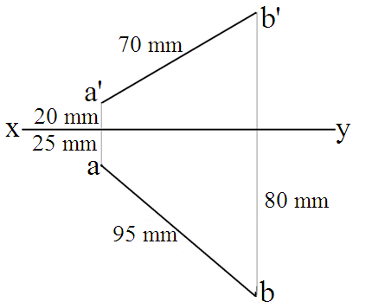
True length of line AB is
(A) | 70 mm
(B) | 80 mm
(C) | 95 mm
(D) | None of the above

130. A cube is resting on HP on a face and the front view and end view are geometrically the same when compared with top view. Which statement is true?
(A) | The cube has one side parallel to VP
(B) | The cube has one side making 30° to VP
(C) | The cube has one side making 60° to VP
(D) | All the above

131. A cube is resting on HP on an edge which is parallel to VP. Which statement is true?
(A) | Front view is a square
(B) | Top view is a square
(C) | Side view is a square
(D) | None of the above

132. A tetrahedron of 50 mm side has
(A) | 4 axes of 50 mm length
(B) | 3 axes of mm length
(C) | 4 axes of mm length
(D) | 4 axes of mm length

133. A hexagonal pyramid 30 mm side of base and 70 mm axis lies on HP on a triangular face. What is the inclination of the axis with HP?
(A) | 30°
(B) | 60°
(C) | 25.4°
(D) | 20.4°

134. A cone of 50 mm diameter 60 mm axis stands on HP on a point of its base circle with axis parallel to VP and making 50° to HP. The plan length of the generator containing P will be
(A) | 19.44 mm
(B) | 25 mm
(C) | 30 mm
(D) | 15 mm

135. The drawing represents the end view from left of a square pyramid 40 mm side of base and 70 mm axis (I angle projection). How is the pyramid?
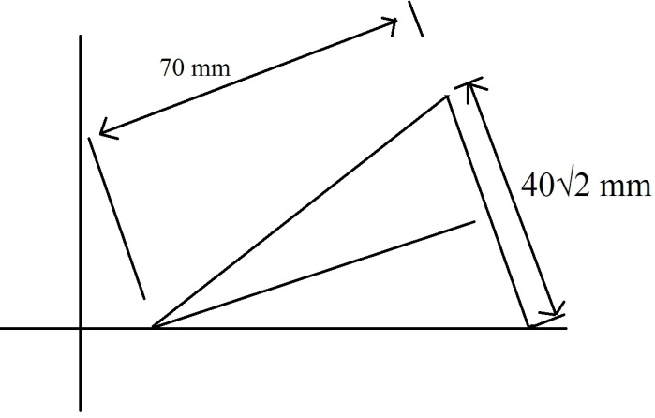
(A) | Lying on HP on a triangular face with axis parallel to VP
(B) | Lying on HP on a slant edge with axis parallel to VP
(C) | Lying on HP on a triangular face with axis perpendicular to VP
(D) | None of the above

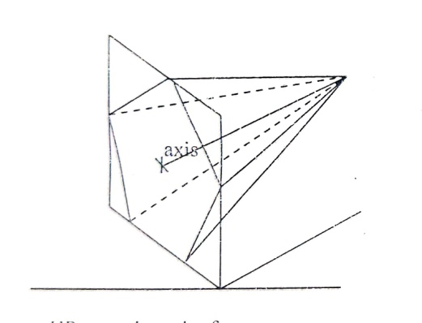
136. When an octahedron is suspended on a string tied at a corner, its top view will be a

(A) | hexagon
(B) | octagon
(C) | square
(D) | rhombus

137. The drawing shows the top view of a polyhedron. Which statement is true for this position?
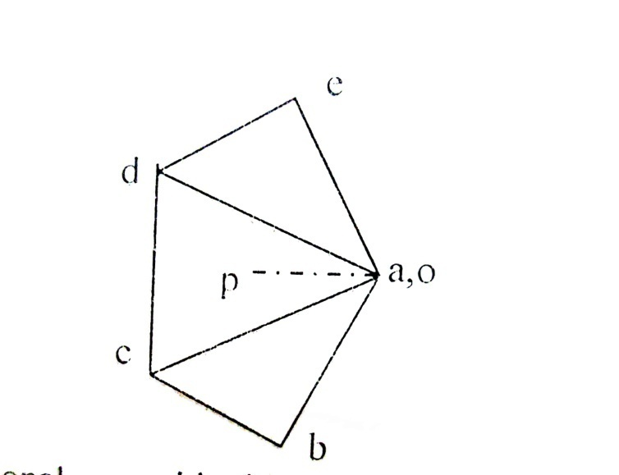
X Y

(A) | Pentagonal pyramid with apex nearer to HP and a slant edge perpendicular to HP
(B) | Pentagonal pyramid with apex nearer to HP and a triangular face perpendicular to VP and inclined to HP
(C) | Pentagonal pyramid with base perpendicular to VP inclined to HP such that the apex is nearer to HP
(D) | Pentagonal pyramid resting on HP on a corner of base with slant edge containing the corner vertical

138. A corn of 50 mm diameter and 50 mm axis length rests on the ground on its base. What is the shape of the front view?
(A) | Equilateral triangle
(B) | Circle
(C) | Isosceles triangle
(D) | Right angled triangle

139. A cube resting on the ground on a face is cut by a cutting plane so that true shape is the biggest possible rhombus. What is the inclination of the cutting plane with the ground?
(A) | 35.26°
(B) | 45°
(C) | 60°
(D) | 30°

140. A hexagonal pyramid lying on HP on triangular face is cut by a plane parallel to HP as shown in figure. What is the true shape of section?
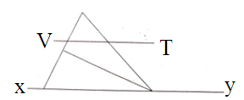
(A) | Triangle
(B) | Trapezium
(C) | Hexagon
(D) | Square

141. Perspective view of lines that are parallel to picture plane and ground plane
(A) | will have actual lengths
(B) | will be parallel to ground line
(C) | will lie on horizon line
(D) | None of the above

142. Central plane in perspective projection is a plane passing
(A) | through the axis of solid
(B) | through the eye parallel to ground plane
(C) | through the eye perpendicular to ground plane
(D) | through the midpoint of axis of solid

143. The front view of station point lies on
(A) | Ground line
(B) | Horizon line
(C) | Picture plane
(D) | Line of heights

144. The reason for taking isometric lengths along the isometric axes is that the lengths along x, y, z axes are inclined to VP by
(A) | 22.8°
(B) | 30°
(C) | 15°
(D) | 35.25°

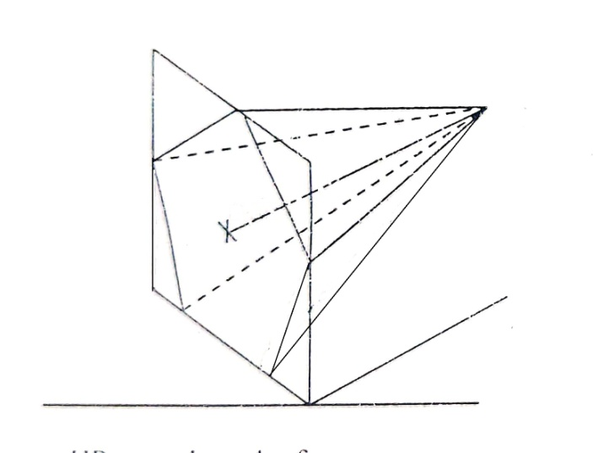
145. Isometric view of a pentagonal pyramid is shown here. Which statement is correct?

(A) | It is lying on HP on a triangular face
(B) | It is lying on HP on a triangular face with axis parallel to VP
(C) | Its axes are perpendicular to VP
(D) | None of the above

146. An area of 20 km² is represented by a rectangle of 90 cm × 800 cm in a map. What is the RF?
(A) | 3:5000
(B) | 9:250
(C) | 1:5000
(D) | 1:3600

147. A backward reading vernier scale capable of reading up to 4 meters is divided into 4 parts of 1 meter each. The left most part is divided into 20 equal parts to represent 5 centimeter each. If the least count required is 5 mm, how will you divide the vernier scale?
(A) | 10 msd divided into 20 equal parts
(B) | 11 msd divided into 12 equal parts
(C) | 11 msd divided into 10 equal parts
(D) | 21 msd divided into 20 equal parts

148. What is meant by diameter of an ellipse?
(A) | Major axis
(B) | Line with end points on the curve, passing through the centre
(C) | Distance between two foci
(D) | (Major axis + Minor axis)/2

149. A ball is thrown from the ground and it just passes over a tree 5 m tall and falls to the ground tracing on a parabolic path. The focus of the curve is on the ground itself. What is the size of the rectangle in which the curve can be drawn?
(A) | 5 m × 5 m
(B) | 5 m × 10 m
(C) | 5 m × 20 m
(D) | 5 m × 25 m

150. Which statement is true for a hyperbola?
(A) | The auxiliary circles are drawn with F1 and F2 as centres
(B) | Asymptote is the tangent to the hyperbola at infinity
(C) | The asymptote divides the semi-transverse axis in the ratio of its eccentricity
(D) | The asymptote divides the transverse axis in the ratio of its eccentricity

151. M10 grade of concrete approximates
(A) | 1 : 3 : 6 mix
(B) | 1 : 1 : 2 mix
(C) | 1 : 2 : 4 mix
(D) | 1 : 1.5 : 3 mix

152. IS. Sieve Nos. 10 mm and 4.75 mm are generally used for grading of
(A) | coarse aggregates
(B) | fine aggregates
(C) | Neither (A) nor (B)
(D) | Both (A) and (B)

153. A brick cut at the corner along the midpoint of adjacent sides, is called as
(A) | queen closer
(B) | king closer
(C) | quoin
(D) | bat

154. The type of foundation in which a cantilever beam is used for joining the two footings is
(A) | raft footing
(B) | strap footing
(C) | combined footing
(D) | strip footing

155. In chain surveying, tie lines are primarily provided
(A) | to check the accuracy of the survey
(B) | to take offsets for detail survey
(C) | to avoid long offsets from chain lines
(D) | to increase the number of chain lines

156. Pick up the method of surveying in which field observations and plotting proceed simultaneously, from the following
(A) | plane table surveying
(B) | chain surveying
(C) | compass surveying
(D) | tachometric surveying

157. The representative fraction of 1/2500 means that the scale is
(A) | 1 cm = 2.5 m
(B) | 1 cm = 15 m
(C) | 1 cm = 25 m
(D) | 1 cm = 2.5 km

158. A back sight
(A) | is always taken on a point of known elevation or can be computed
(B) | is added to the known level to obtain the instrument height
(C) | taken on an inverted staff is treated as negative
(D) | All the above

159. When concrete is to be laid under water, …………… is used.
(A) | Rapid Hardening Cement
(B) | Ordinary Portland Cement
(C) | Quick Setting Cement
(D) | Low Heat Cement

160. Stiffeners are used in plate girder
(A) | to reduce the compressive stress
(B) | to reduce the shear stress
(C) | to take the bending stress
(D) | to avoid the buckling of web plate

161. Which of the following is known as the inequality of Clausius?
(A) | Cyclic integral of
(B) | Cyclic integral of
(C) | Cyclic integral of
(D) | Cyclic integral of

162. If in the equation pv^{n} = C, the value of n = ∝, then the process is called
(A) | constant volume process
(B) | adiabatic process
(C) | constant pressure process
(D) | isothermal process

163. The calorific value of gaseous fuel is expressed in
(A) | kJ
(B) | kJ/kg
(C) | kJ/m²
(D) | kJ/m³

164. Tool signature of a single point cutting tool consists of …………… dimensions.
(A) | 4
(B) | 5
(C) | 6
(D) | 7

165. Arbor is a component connected with
(A) | lathe
(B) | milling
(C) | shaper
(D) | grinder

166. Which among the following is not a frequency distribution?
(A) | Bar chart
(B) | Pie chart
(C) | Control chart
(D) | Histogram
167. Least count value of Vernier height gauge is
(A) | 0.001 mm
(B) | 0.01 mm
(C) | 0.002 mm
(D) | 0.02 mm
168. Which among the following is not related to inventory control?
(A) | ABC
(B) | VED
(C) | TQM
(D) | FSN

169. Which among the following is an ideal reversible closed thermodynamic cycle?
(A) | Otto cycle
(B) | Diesel cycle
(C) | Carnot cycle
(D) | Brayton cycle

170. A thermodynamic quantity equivalent to the total heat content of a system is
(A) | Entropy
(B) | Enthalpy
(C) | Latent heat
(D) | Specific heat

171. What is the condition of an electromagnetic induction?
(A) | There must be a relative motion between the coil of wire and the galvanometer
(B) | There must be a relative motion between the galvanometer and a magnet
(C) | There must be a relative motion between the galvanometer and generator
(D) | There must be a relative motion between the coil of wire and a magnet

172. Calculate the emf when the flux is given by 3 sin t + 4 cos t in a coil with 1 turn.
(A) | 3 cos t – 4 sin t
(B) | –3 cos t + 4 sin t
(C) | 7
(D) | 5

173. Which among the following is correct with regard to the use of MI Ammeter and MC Ammeter?
(A) | Both are used to measure AC current only
(B) | Both are used to measure DC current only
(C) | Both are used to measure current and voltages
(D) | MI ammeter is used to measure both AC and DC but MC ammeter only to measure DC

174. What are the coils in a Wattmeter?
(A) | Armature and Field
(B) | There is only one coil
(C) | Series and shunt coils
(D) | Low Power Factor and High Power Factor coils

175. The range of the Voltmeter can be increased by
(A) | adding a high resistance series resistor to the pressure coil
(B) | adding a low resistance series resistor to the pressure coil
(C) | adding a high resistance parallel resistor to the pressure coil
(D) | adding a low resistance parallel resistor to the pressure coil

176. Energy meters measure units in
(A) | Current consumed
(B) | Power in Watts consumed
(C) | kWh units consumed
(D) | Voltage consumed

177. Power in an RLC circuit is
(A) | always zero
(B) | more than in a pure R circuit
(C) | equal to power consumed by R only
(D) | equal to power consumed by R, L and C

178. Find the delta equivalent of 3 identical resistors of 3 ohms connected in star.
(A) | 9 Ω in each leg
(B) | 2 Ω in each leg
(C) | It is different in each leg and so cannot calculate
(D) | 1 Ω in each leg

179. On increasing the number of turns on a coil
(A) | the inductance of the coil is increased
(B) | the inductance of the coil is decreased
(C) | the permeability of its core is increased
(D) | the permeability of its core is decreased

180. Norton’ and Thevenin’s theorems are
(A) | applicable to DC circuits only
(B) | dual of each other
(C) | not applicable for analyzing Transistors
(D) | applicable for finding only voltages across a resistor

181. The forward characteristic of a diode has a slope of approximately 50 mA/V at a desired point. The approximate incremental resistance of the diode is:
(A) | 50 Ω
(B) | 35 Ω
(C) | 20 Ω
(D) | 10 Ω

182. In a half wave rectifier, the sine wave input is 200 sin 300t. The average value of output voltage is?
(A) | 57.876 V
(B) | 67.453 V
(C) | 63.694 V
(D) | 76.987 V

183. Which of the following is true for a bridge rectifier?
(A) | The peak inverse voltage or PIV for the bridge rectifier is lower when compared to an identical center tapped rectifier
(B) | The output voltage for the center tapped rectifier is lower than the identical bridge rectifier
(C) | A transformer of higher number of coils is required for center tapped rectifier than the identical bridge rectifier
(D) | All of the above

184. Commonly used electrical strain gauge is
(A) | open type
(B) | closed type
(C) | unbounded type
(D) | bonded type
185. What is a thermopile?
(A) | Single thermocouple
(B) | Series-parallel connection of thermocouples
(C) | Parallel connection of thermocouples
(D) | Series of thermocouples

186. Which equation represents AM waves?
(A) | [1 + m(t)].c(t)
(B) | [1 – m(t)].c(t)
(C) | [1 + m(t)].2c(t)
(D) | [1 + 2m(t)].c(t)

187. Why a sinusoidal signal is considered for analog communication?
(A) | It moves in both positive and negative direction
(B) | It is positive for one half cycle
(C) | It is negative for one half cycle
(D) | It has infinite number of amplitudes in the range of values of the independent variable

188. Relationship between amplitude and frequency is represented by
(A) | Time-domain plot
(B) | Phase-domain plot
(C) | Frequency-domain plot
(D) | Amplitude-domain plot

189. When will aliasing takes place
(A) | Sampling signals less than Nyquist Rate
(B) | Sampling signals more than Nyquist Rate
(C) | Sampling signals equal to Nyquist Rate
(D) | Sampling signals at a rate which is twice of Nyquist Rate

190. Which of the following is true about the temperature coefficient (TC) of the Zener diode?
(A) | For Zener voltage less than 5 V, TC is negative
(B) | For Zener voltage around 5V, TC can be made zero
(C) | For higher values of Zener voltage, TC is positive
(D) | All of the above

191. The small extremely fast, RAM’s are called as
(A) | Cache
(B) | Heaps
(C) | Accumulators
(D) | Stacks

192. Deadlock prevention is a set of methods
(A) | to ensure that at least one of the necessary conditions cannot hold
(B) | to ensure that all of the necessary conditions do not hold
(C) | to decide if the requested resources for a process have to be given or not
(D) | to recover from a deadlock

193. In any operating system, a process can be terminated due to
(A) | normal exit
(B) | fatal error
(C) | killed by another process
(D) | All of the above

194. A grammar that produces more than one parse tree for some sentence is called
(A) | Ambiguous
(B) | Unambiguous
(C) | Regular
(D) | None of the above

195. In assembly language, instructions like MOV or ADD are known as
(A) | Opcodes
(B) | Operands
(C) | Commands
(D) | None of the above

196. The network layer that handles units of data is known as
(A) | bits
(B) | frames
(C) | packets
(D) | None of the above

197. A network layer protocol of internet is
(A) | ethernet
(B) | internet protocol
(C) | hypertext transfer protocol
(D) | None of the above

198. An IPv6 address has a size of
(A) | 32 bits
(B) | 64 bits
(C) | 128 bits
(D) | 265 bits

199. In the programming language of C, which of these data types can have variable sizes?
(A) | int
(B) | struct
(C) | float
(D) | double

200. Which multiple access technique is used by IEEE 802.11 standard for wireless LAN?
(A) | CDMA
(B) | CSMA/CA
(C) | ALOHA
(D) | None of the above

